Data Figures_rough

## Data Visualization - BIOL 708

library(here)

here() starts at /Users/amyyoger/Library/Mobile Documents/com~apple~CloudDocs/SFSU/Classes/BIO 708 Simonis/GitHub/BIO-708

library(tidyverse)

Warning: package 'lubridate' was built under R version 4.3.1

── Attaching core tidyverse packages ──────────────────────── tidyverse 2.0.0 ──  
✔ dplyr 1.1.3 ✔ readr 2.1.4  
✔ forcats 1.0.0 ✔ stringr 1.5.0  
✔ ggplot2 3.4.3 ✔ tibble 3.2.1  
✔ lubridate 1.9.3 ✔ tidyr 1.3.0  
✔ purrr 1.0.2

── Conflicts ────────────────────────────────────────── tidyverse_conflicts() ──  
✖ dplyr::filter() masks stats::filter()  
✖ dplyr::lag() masks stats::lag()  
ℹ Use the conflicted package (<http://conflicted.r-lib.org/>) to force all conflicts to become errors

library(readr)  
  
se <- read_csv("https://raw.githubusercontent.com/OHI-Science/data-science-training/master/data/se.csv")

Rows: 453 Columns: 7  
── Column specification ────────────────────────────────────────────────────────  
Delimiter: ","  
chr (5): region, state, code, park_name, type  
dbl (2): visitors, year  
  
ℹ Use `spec()` to retrieve the full column specification for this data.  
ℹ Specify the column types or set `show_col_types = FALSE` to quiet this message.

ggplot(se)+ geom_line(aes(x=year,y=visitors, color=state))+labs(y='visitation') +  
 labs(x = "Year", y = "Visitors")+  
 ggtitle("Visitation Trends in US South East National Parks between 1972-2016")

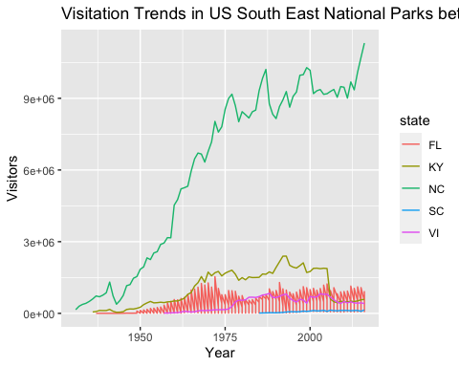

acadia <- read_csv("https://raw.githubusercontent.com/OHI-Science/data-science-training/master/data/acadia.csv")

Rows: 98 Columns: 7  
── Column specification ────────────────────────────────────────────────────────  
Delimiter: ","  
chr (5): region, state, code, park_name, type  
dbl (2): visitors, year  
  
ℹ Use `spec()` to retrieve the full column specification for this data.  
ℹ Specify the column types or set `show_col_types = FALSE` to quiet this message.

ggplot(data = acadia) +   
 geom_point(aes(x = year, y = visitors)) +  
 geom_line(aes(x = year, y = visitors)) +  
 geom_smooth(aes(x = year, y = visitors)) +  
 labs(title = "Acadia National Park Visitation between 1920 and 2020",  
 y = "Visitation",  
 x = "Year") +  
 theme_bw()

`geom_smooth()` using method = 'loess' and formula = 'y ~ x'

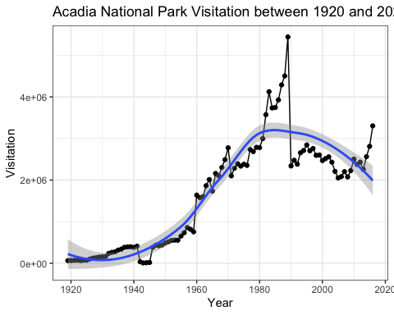

## Note:

This week was a little stressful with personal matters, unfortunately, so I wasn’t able to give this assignment my all in terms of using relevant data to my project. I found it helpful instead to go back and slowly go through the steps to learn how to make graphs using the National Park data. I understand if this means a lower grade- and I look forward to continue working on my ggplot skills! My lab research techs are hoping to send me relevant data this week and I am excited to play around with that in the coming weeks. Thank you!